**Problem Statement:**

You work for XYZ Corporation that uses on premise solutions and a limited

number of systems. With the increase in requests in their application, the load

also increases. So, to handle the load the corporation has to buy more systems

almost on a regular basis. Realizing the need to cut down the expenses on

systems, they decided to move their infrastructure to AWS.

**Tasks To Be Performed:**

1. Manage the scaling requirements of the company by:

a. Deploying multiple compute resources on the cloud as soon as the

load increases and the CPU utilization exceeds 80%

b. Removing the resources when the CPU utilization goes under 60%

2. Create a load balancer to distribute the load between compute resources.

3. Route the traffic to the company’s domain.

First Create launch Template

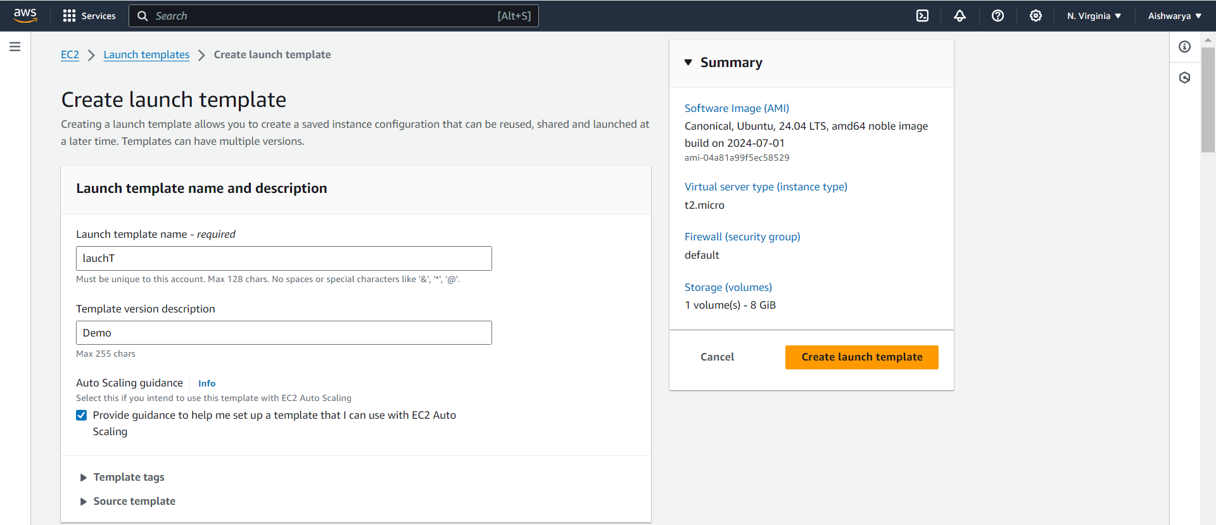

Create Auto Scaling group with above created Launch template

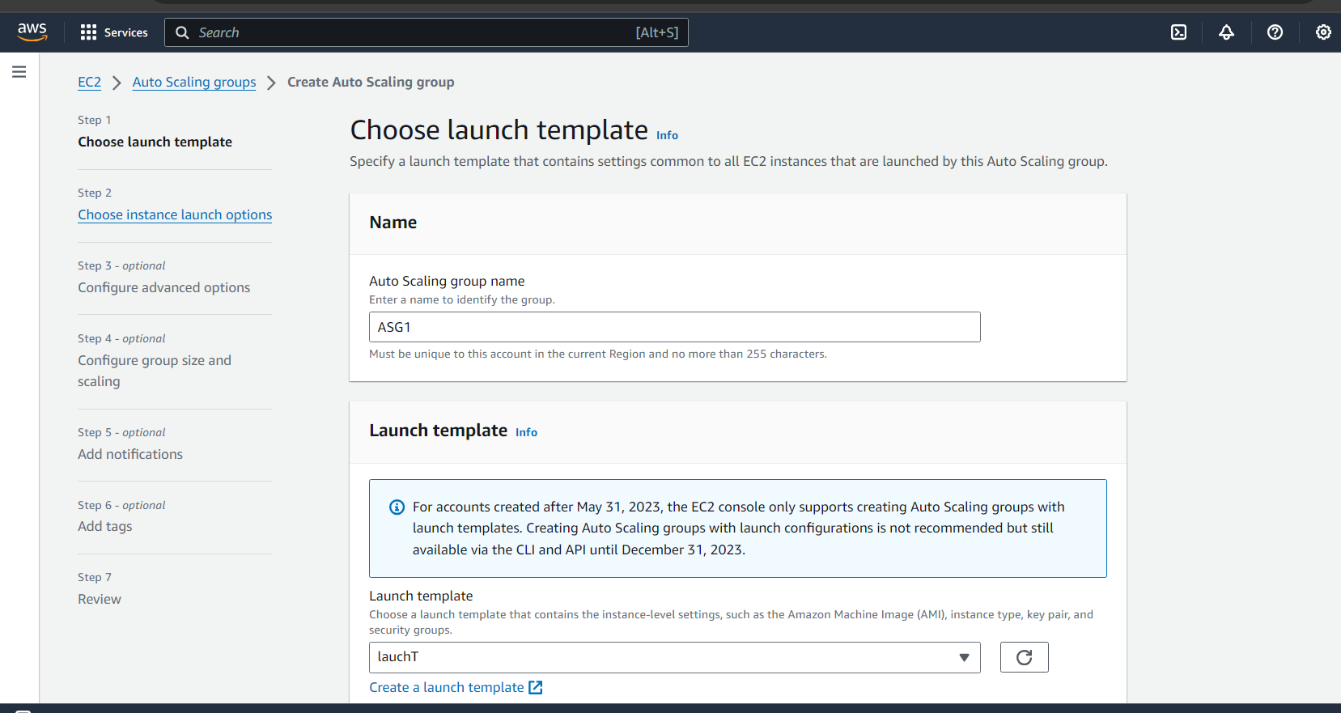

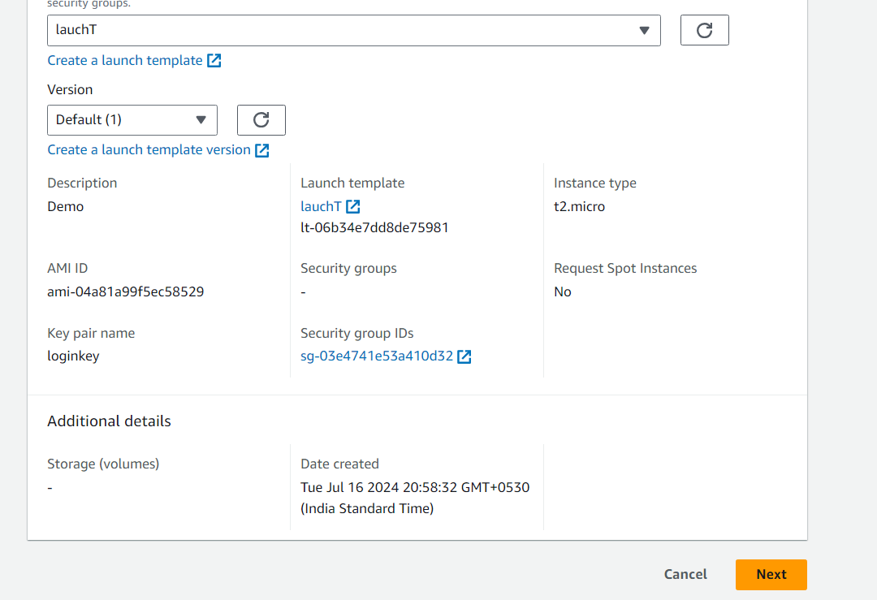

Next

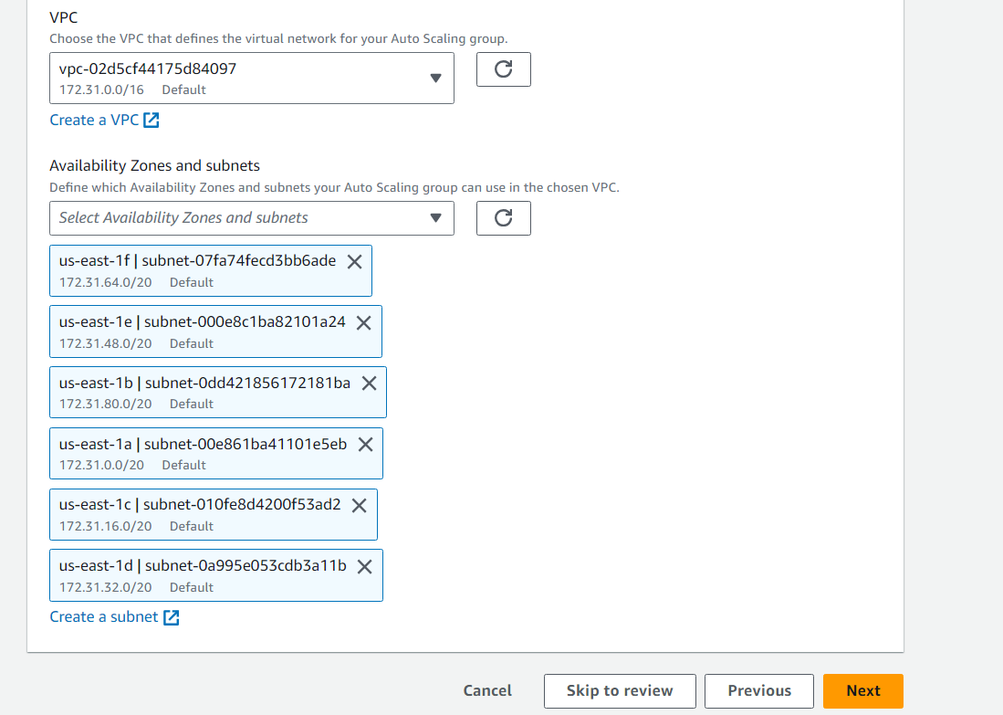

Next Select the desired, minimum and max capacity of ASG

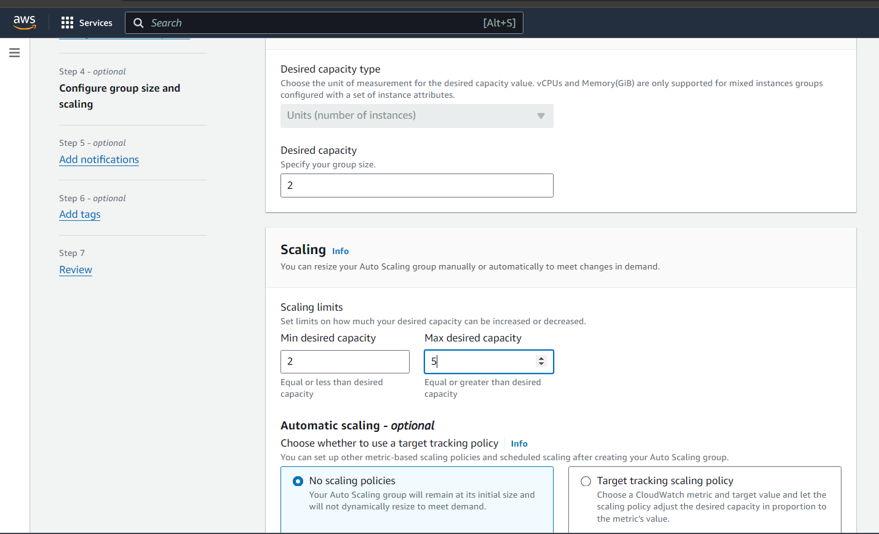

Review all and create Auto Scaling Group

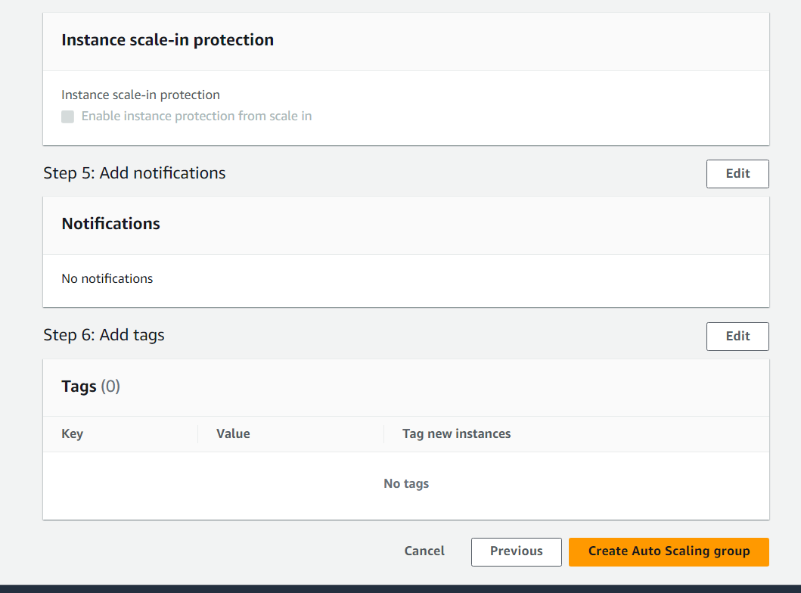

As minimum 2 instances we choose so by default 2 instances are created

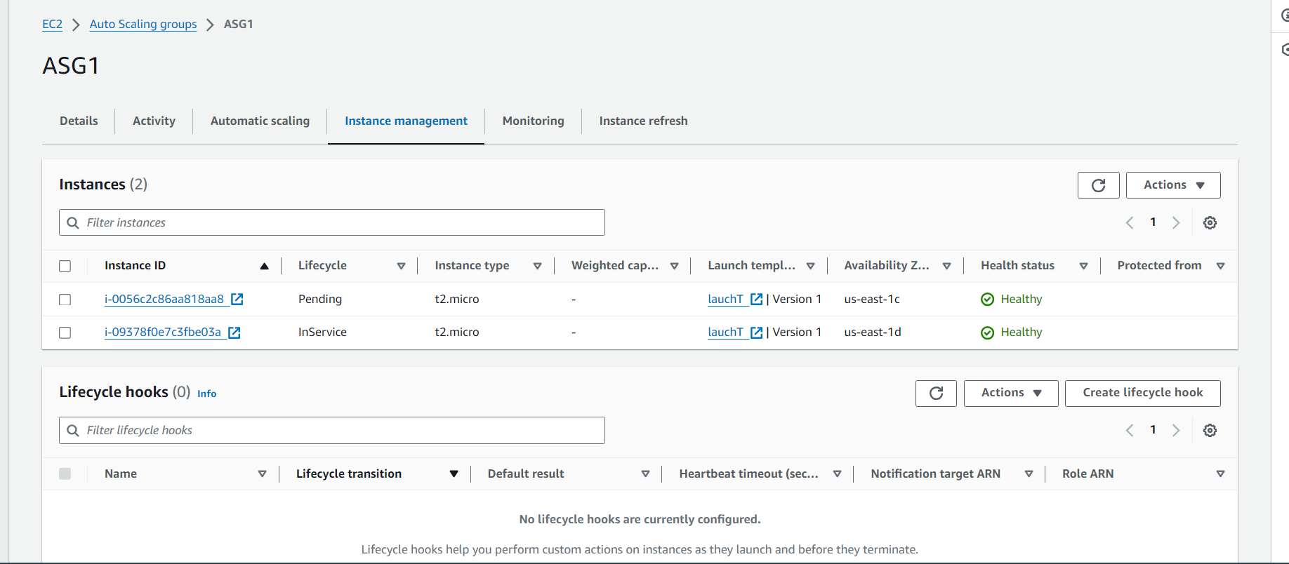

As demo Deploying 2 compute resources on the cloud as soon as the

load increases and the CPU utilization exceeds 80%

.

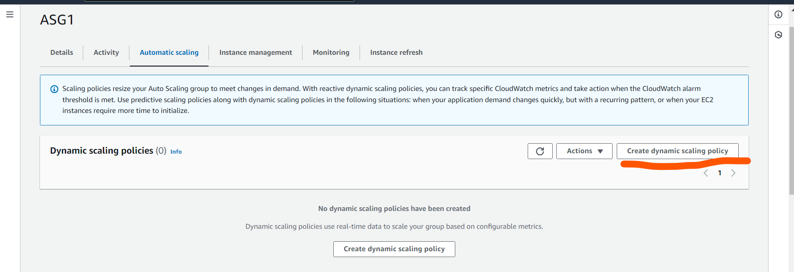

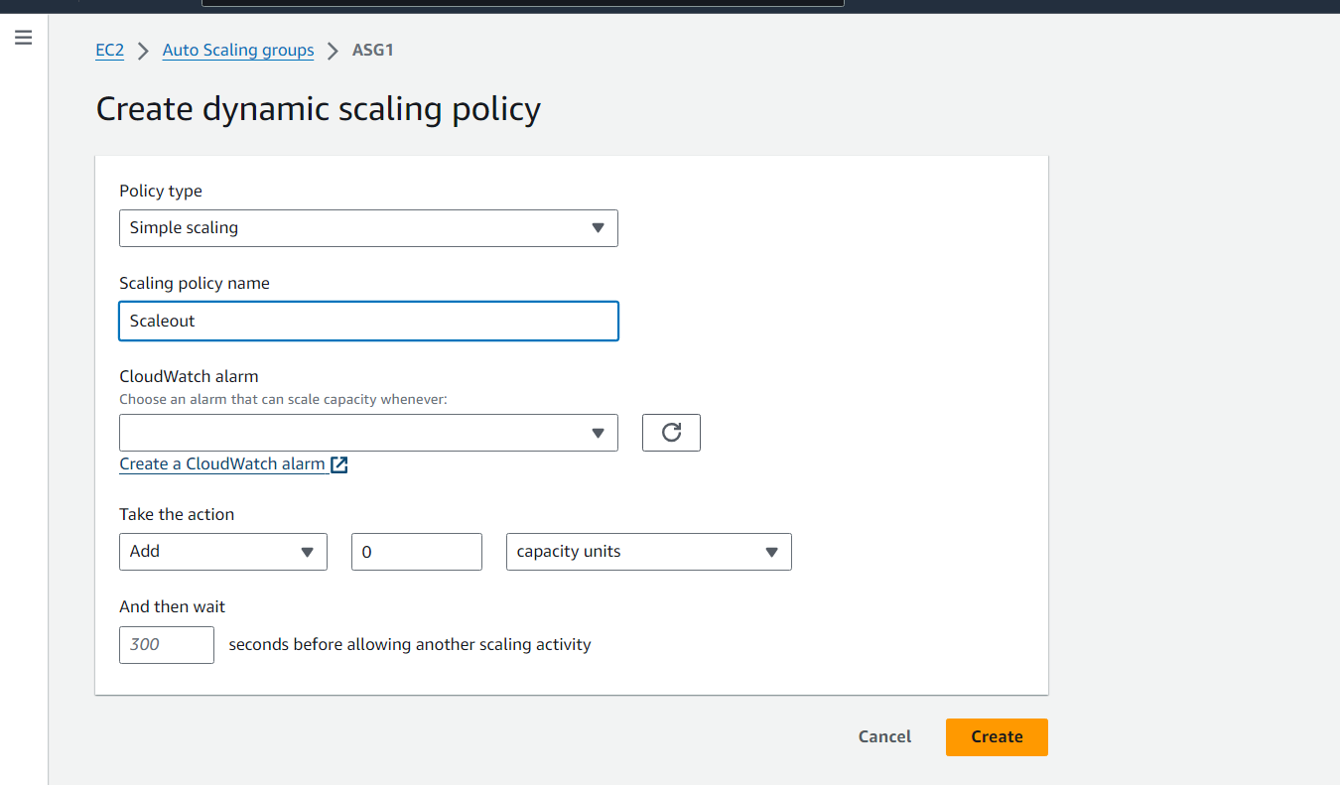

First create cloudwatch alarm

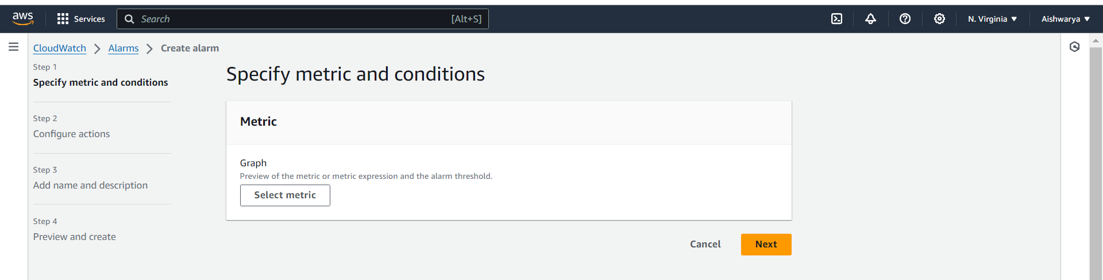

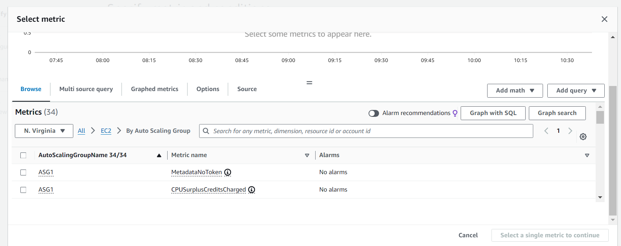

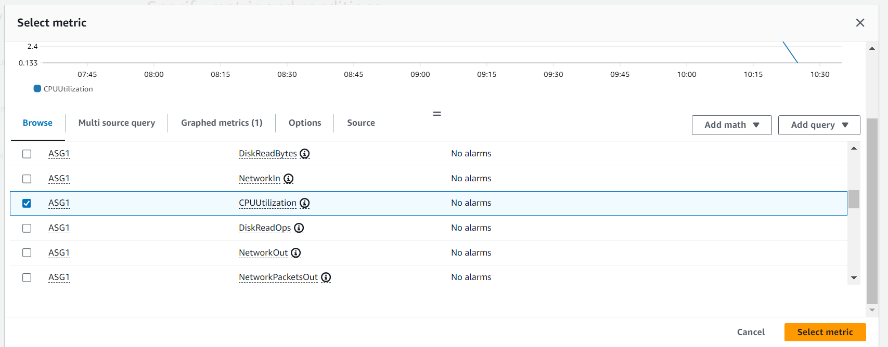

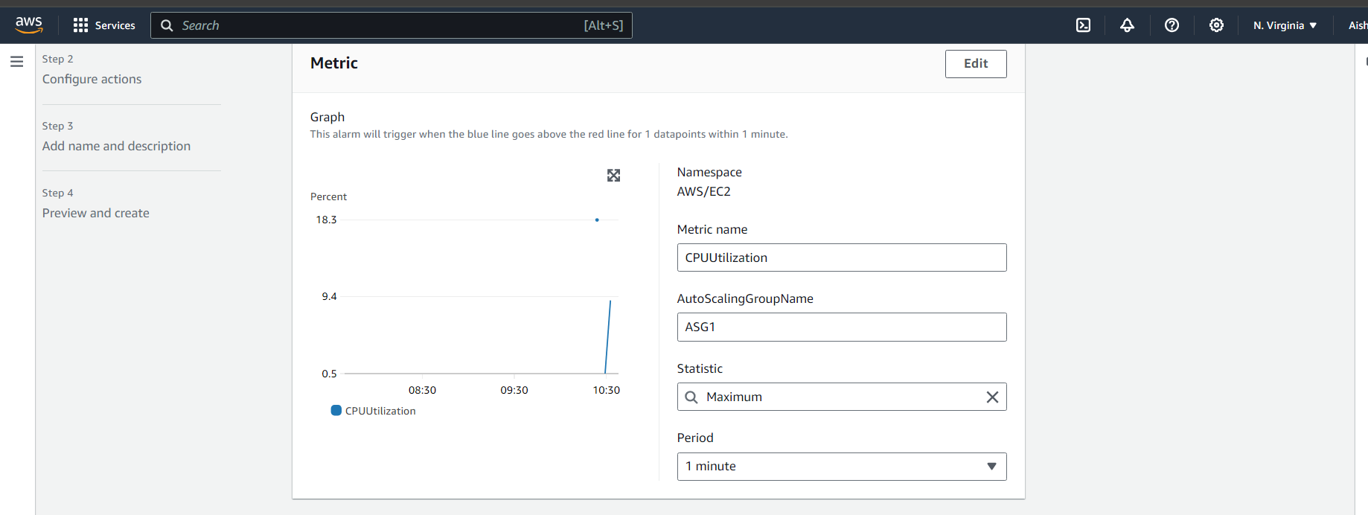

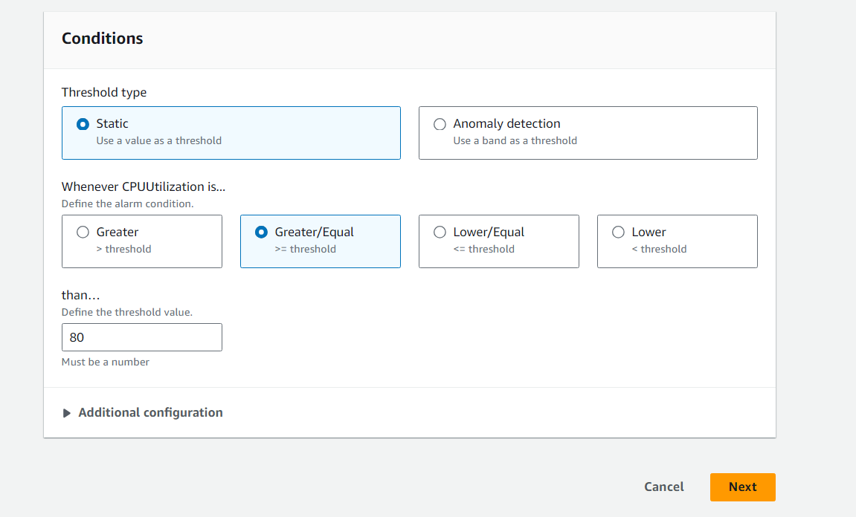

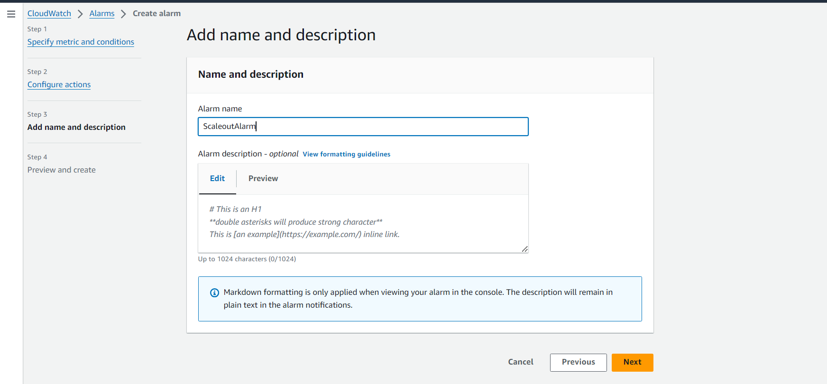

Review all and create alarm

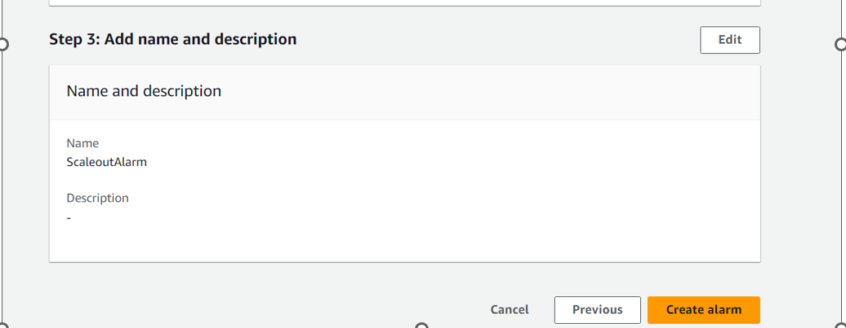

Select the cloudwatch alarm and add 2 instances when cpu utilization >=80%

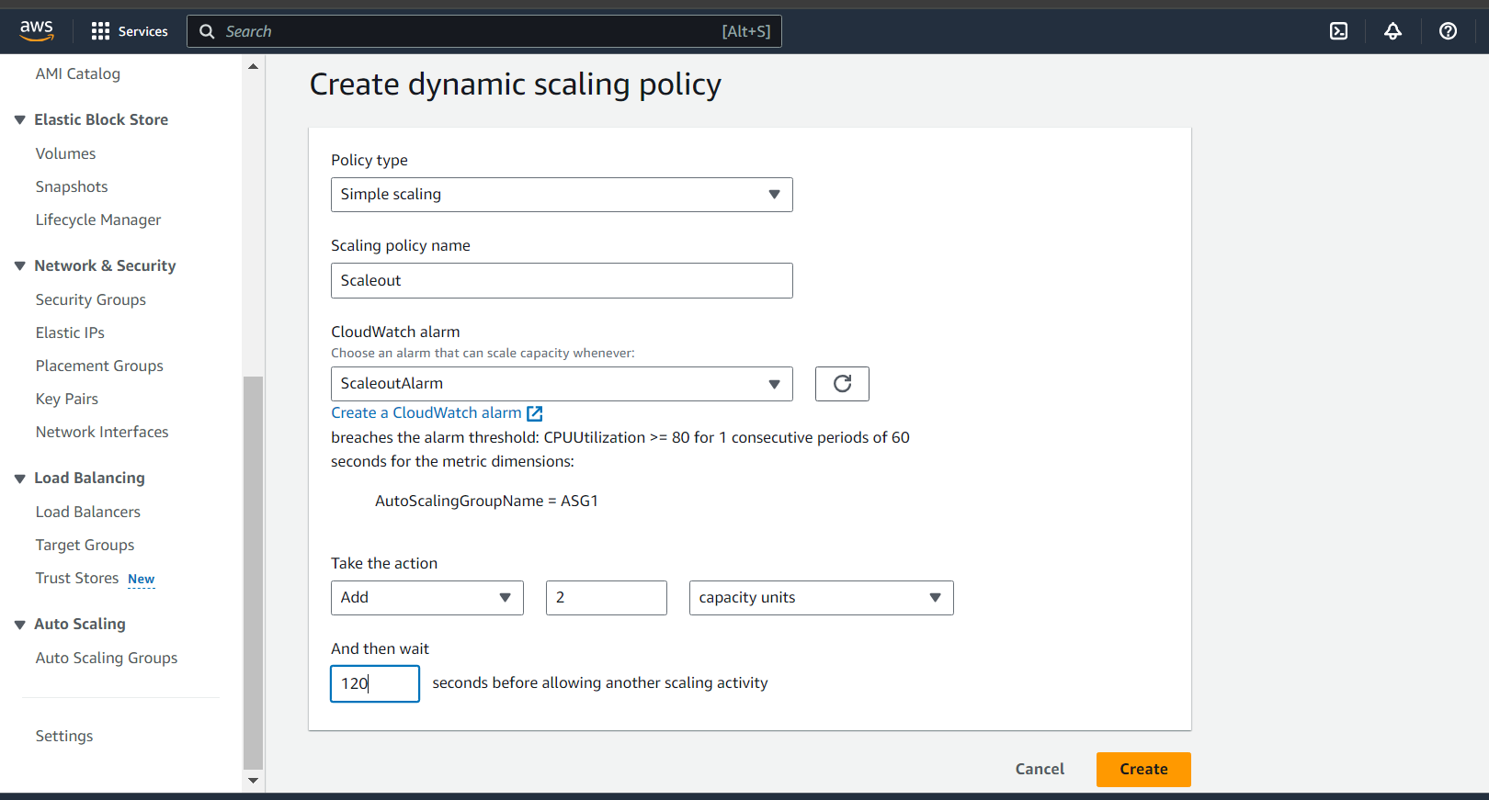

Now it is in Ok state

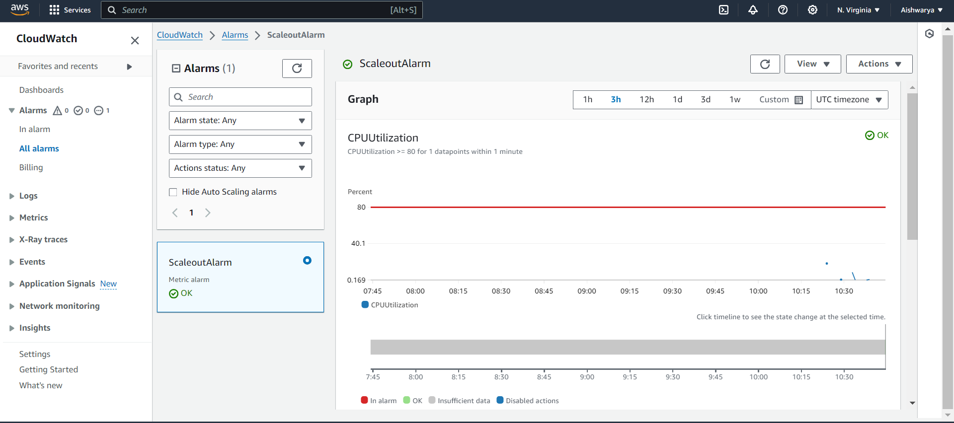

Connect to any of the instance and increase load as below

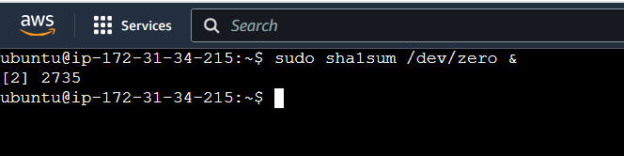

As load increases above 80% it increases 2 instance in ASG

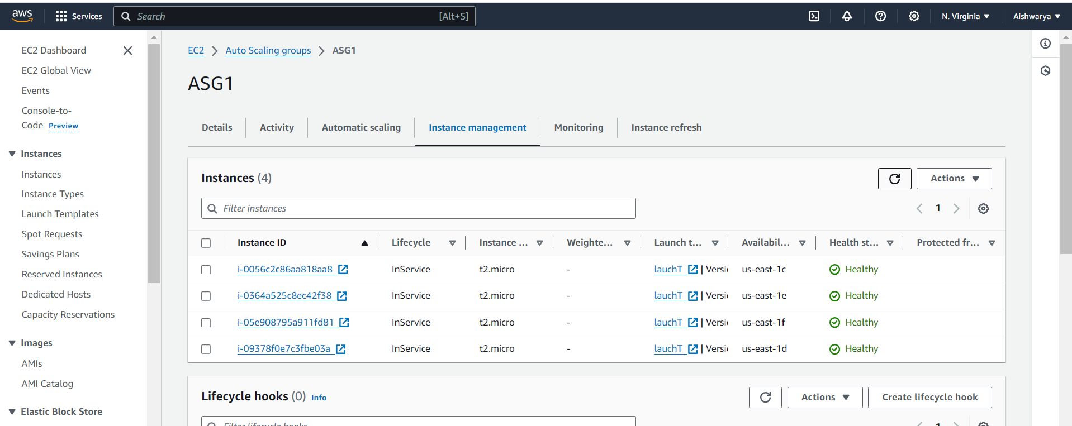

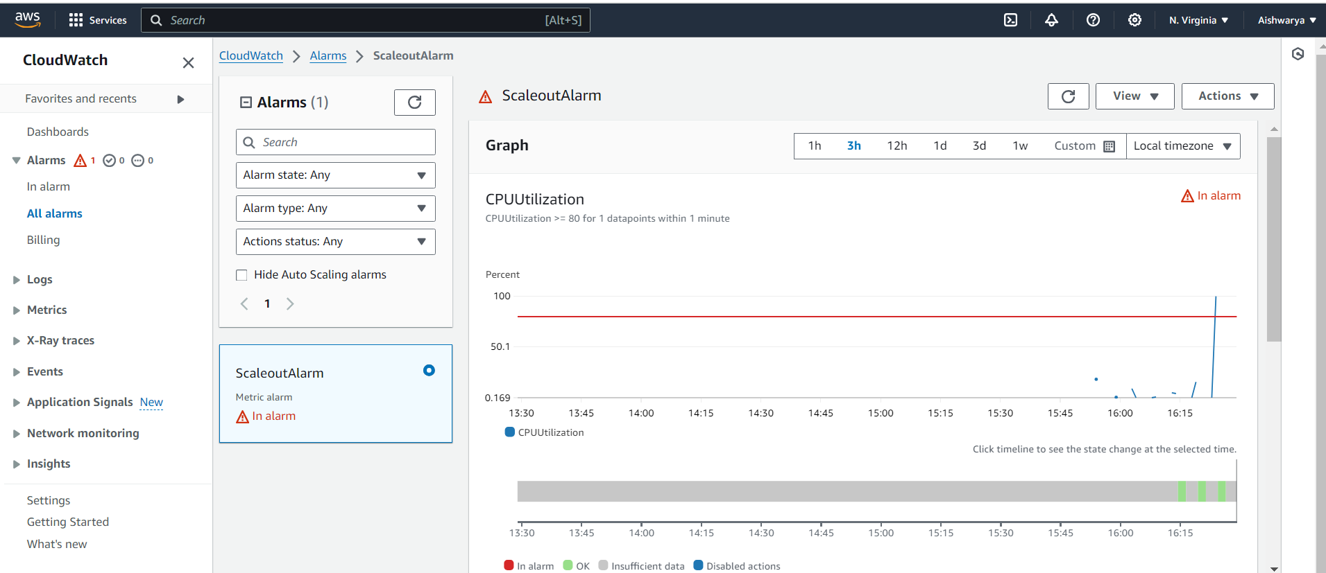

b. As demo Removing the resources when the CPU utilization goes under 60%

Create another dynamic policy

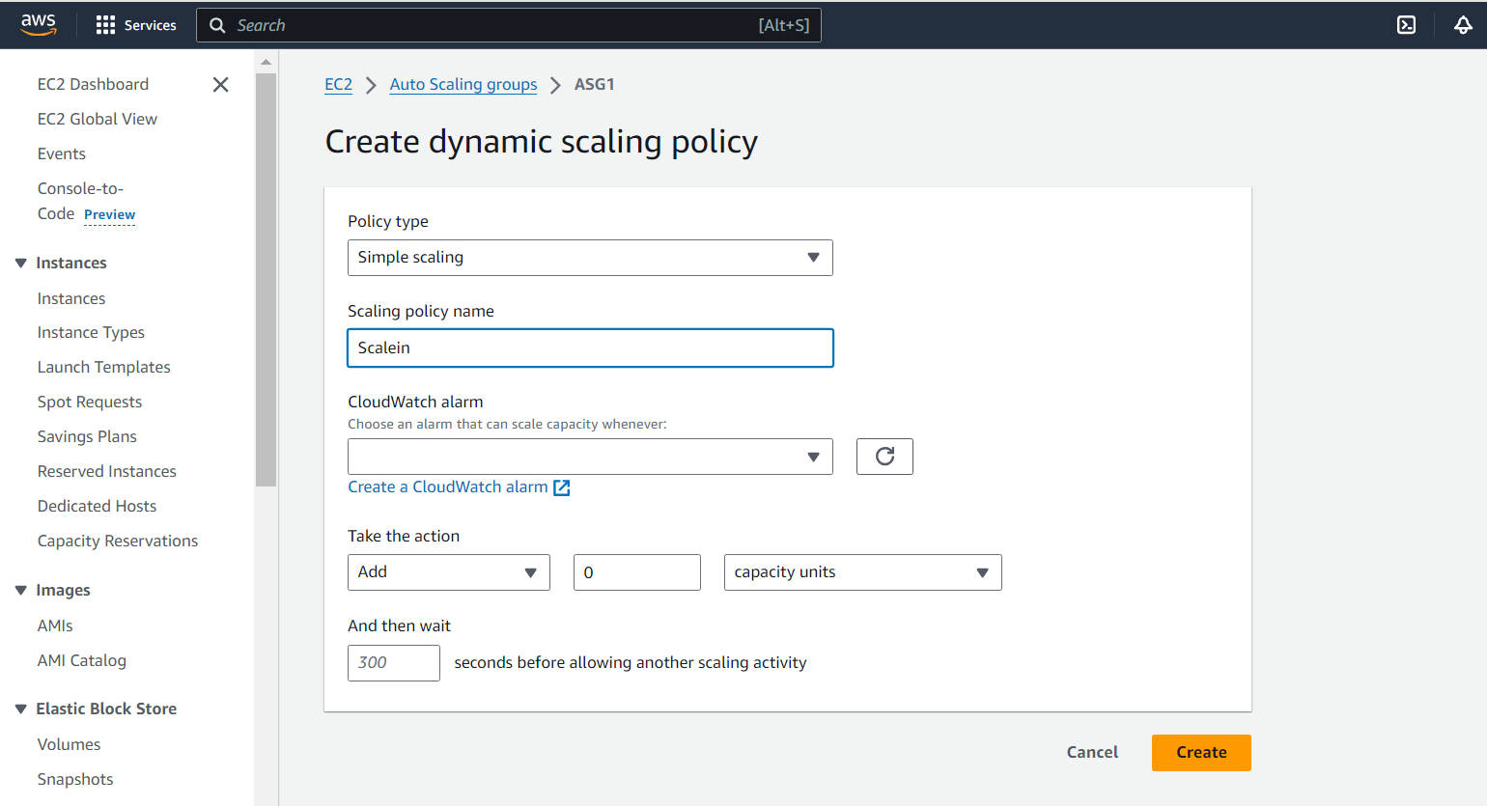

create cloudwatch alarm

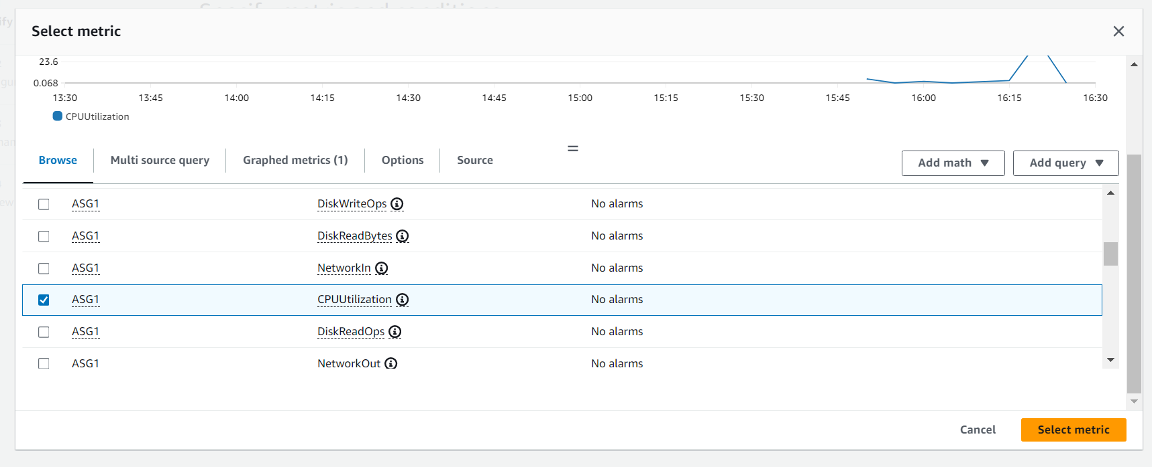

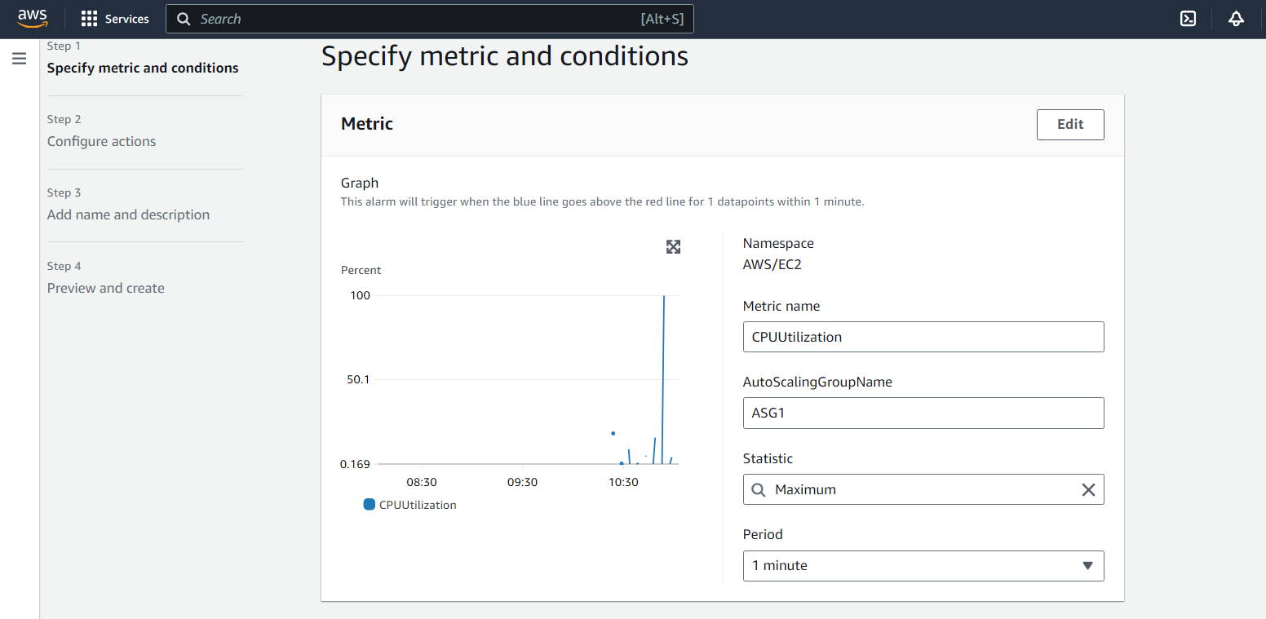

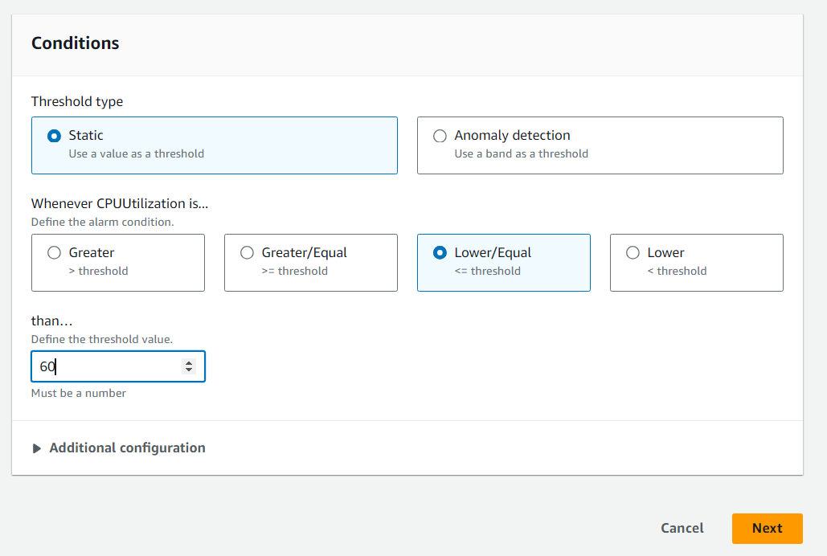

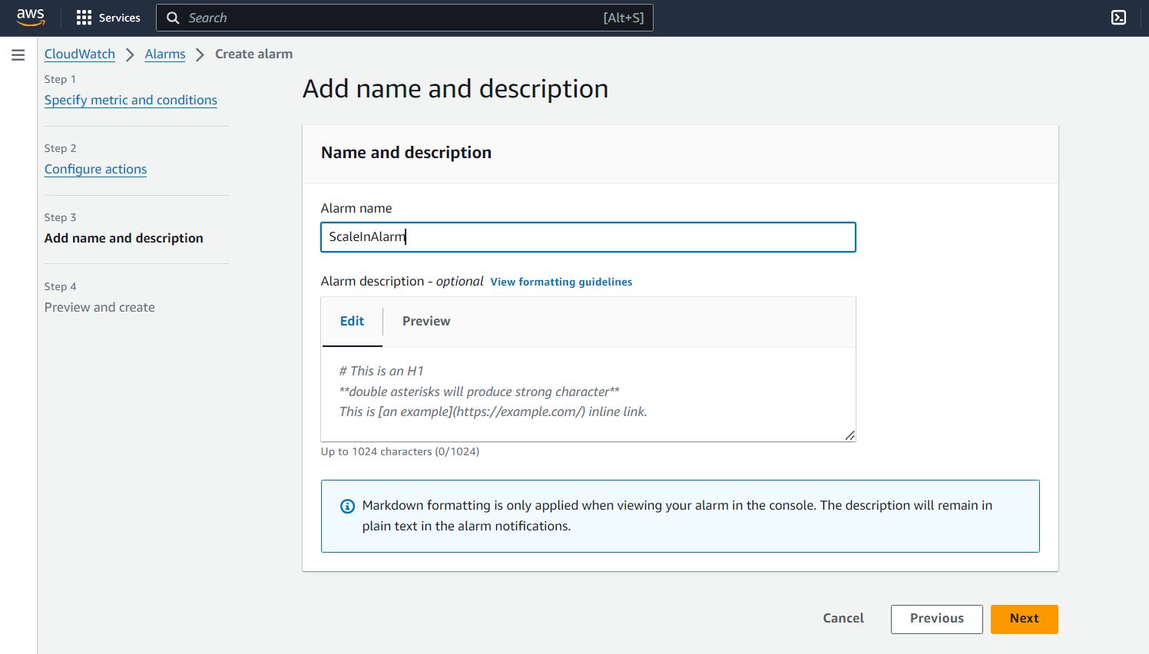

Review all and create

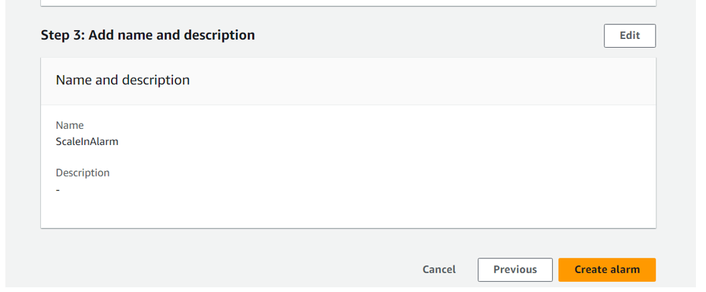

Select the alarm and create policy

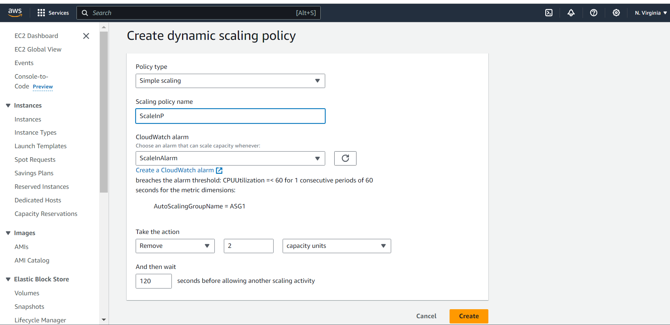

Now decrease 2 instances As I closed previous loaded instance.

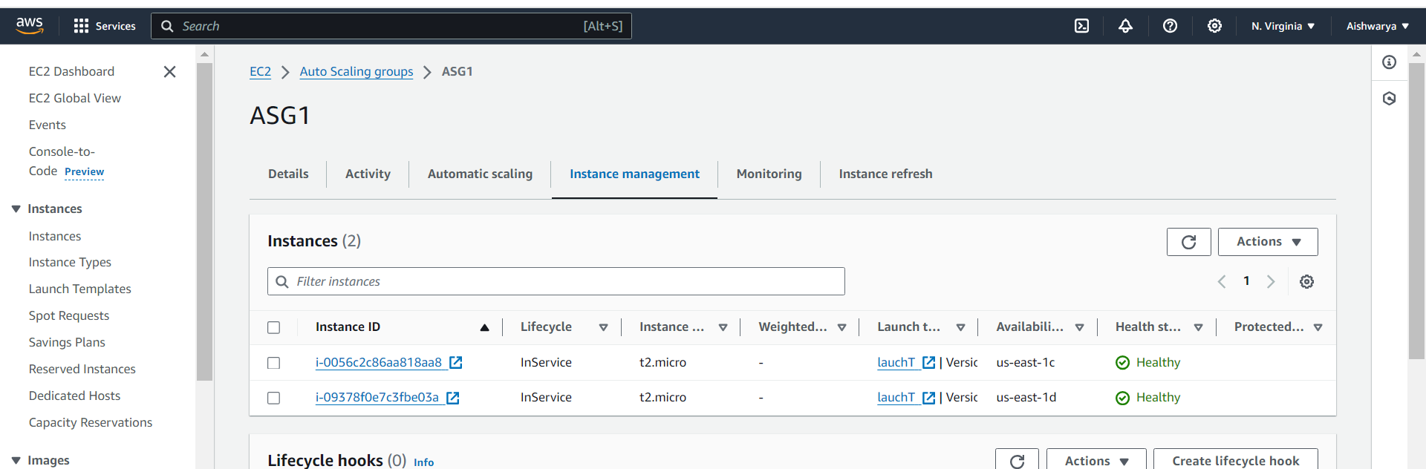

2. Create a load balancer to distribute the load between compute resources.

First Create TG

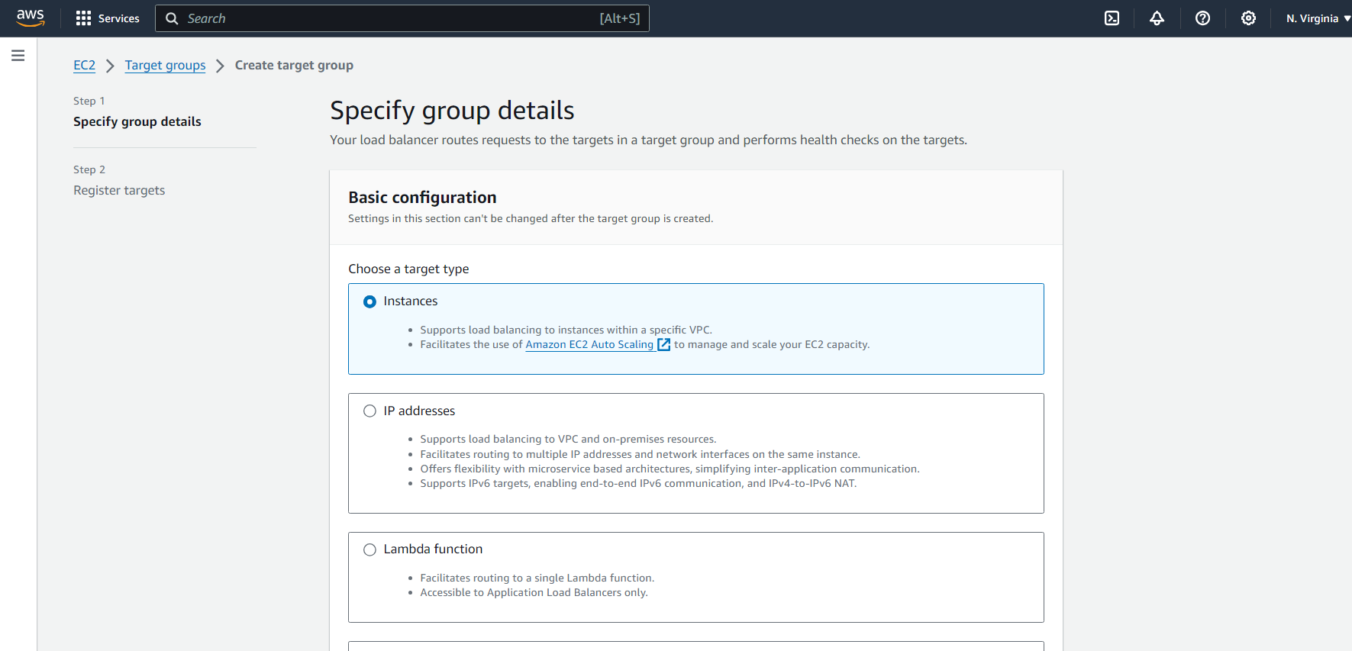

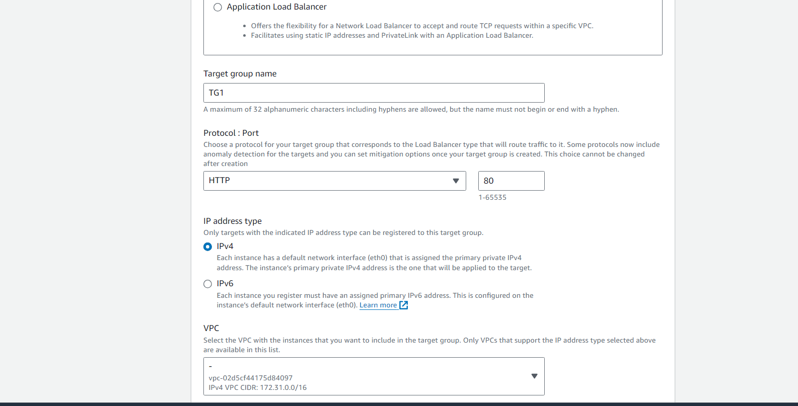

Next

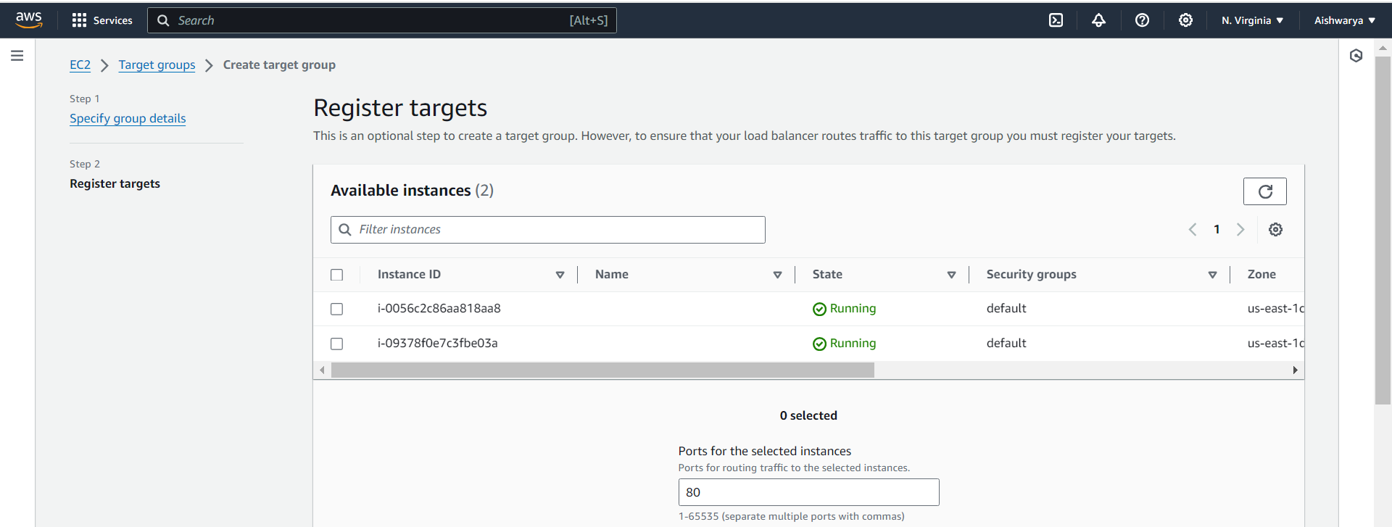

Create target group with no instance.

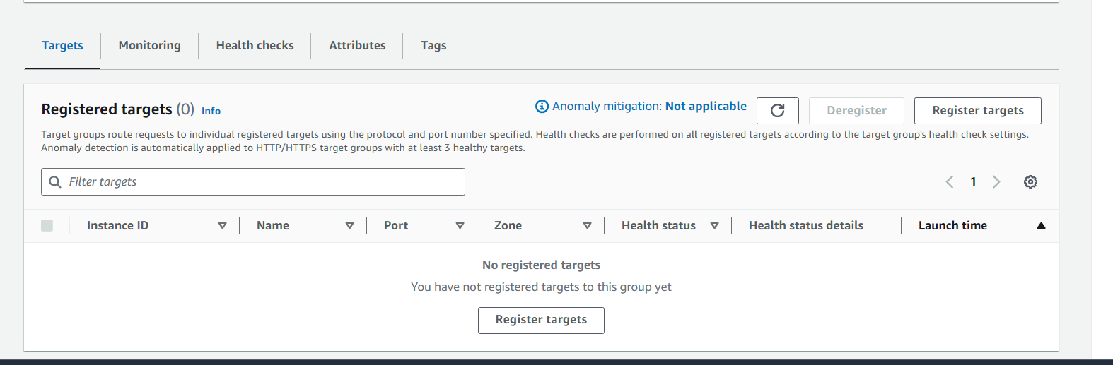

Once we attach load balancer to ASG it will have instances which are created by ASG

Now Create Load balancer with TG

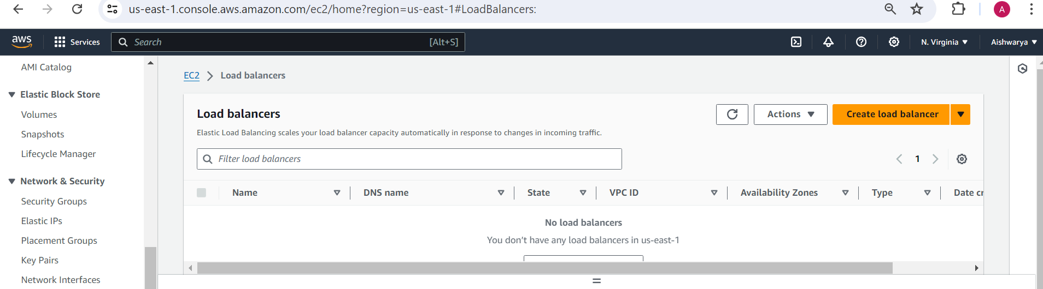

Choose application load balancer

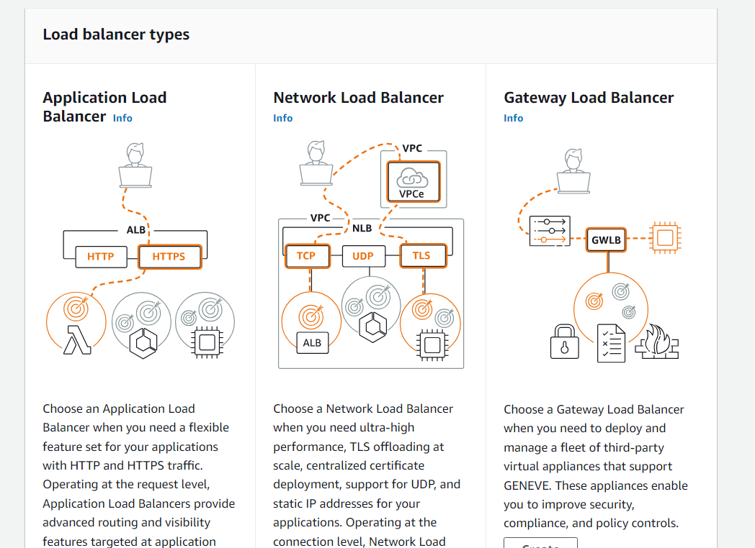

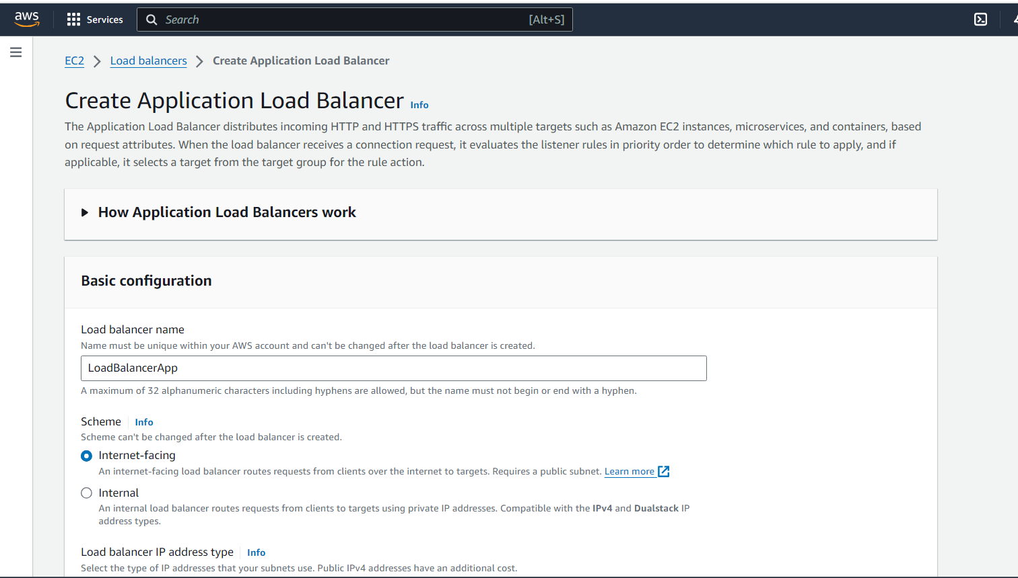

Select AZ

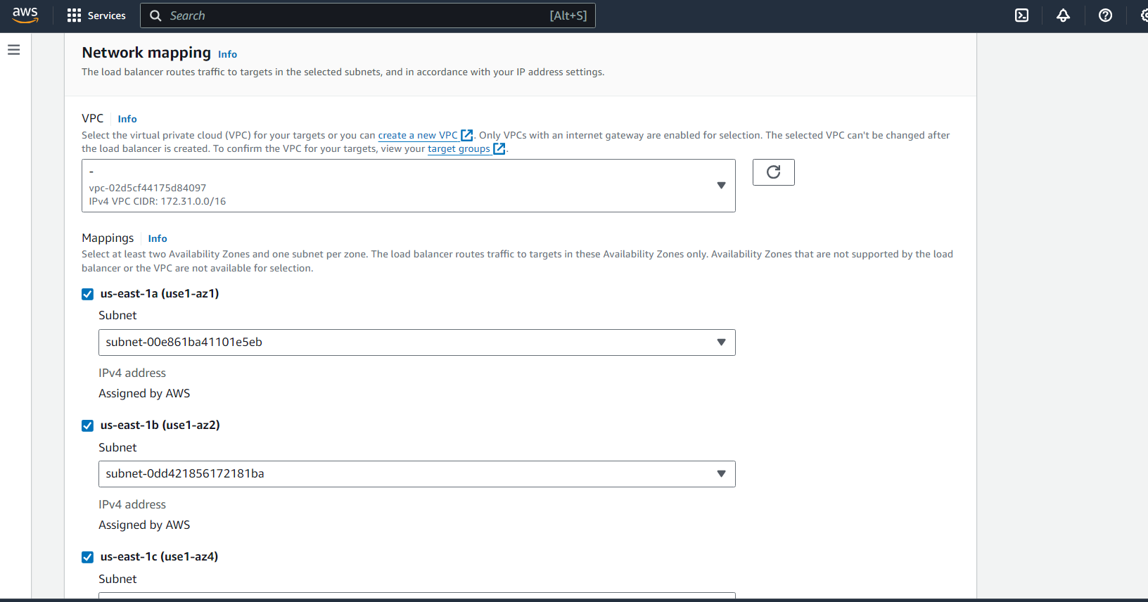

Put all default and create load balancer

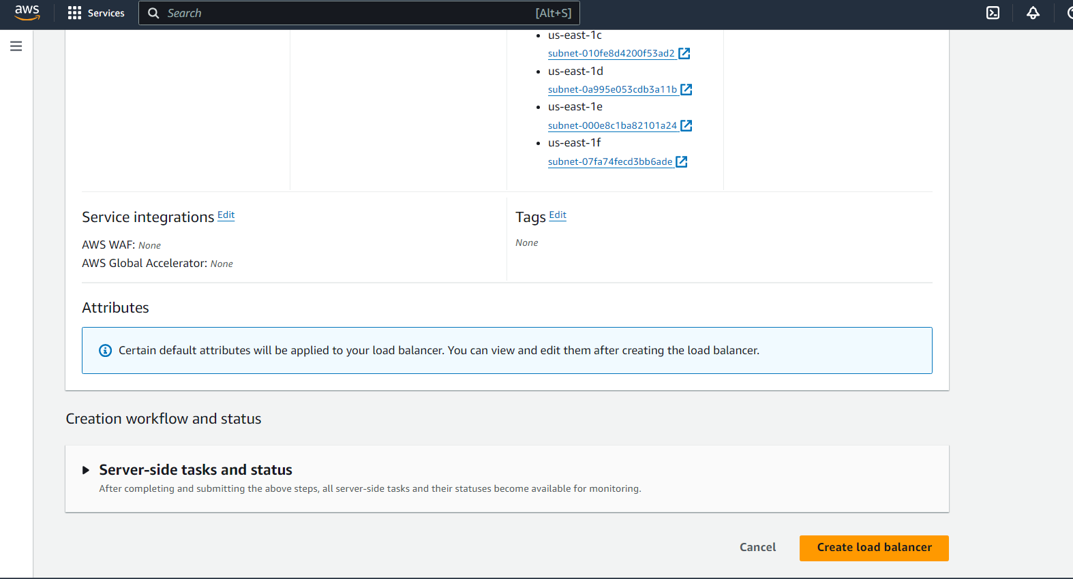

Now to attach it to ASG

Go to ASG and under details tab

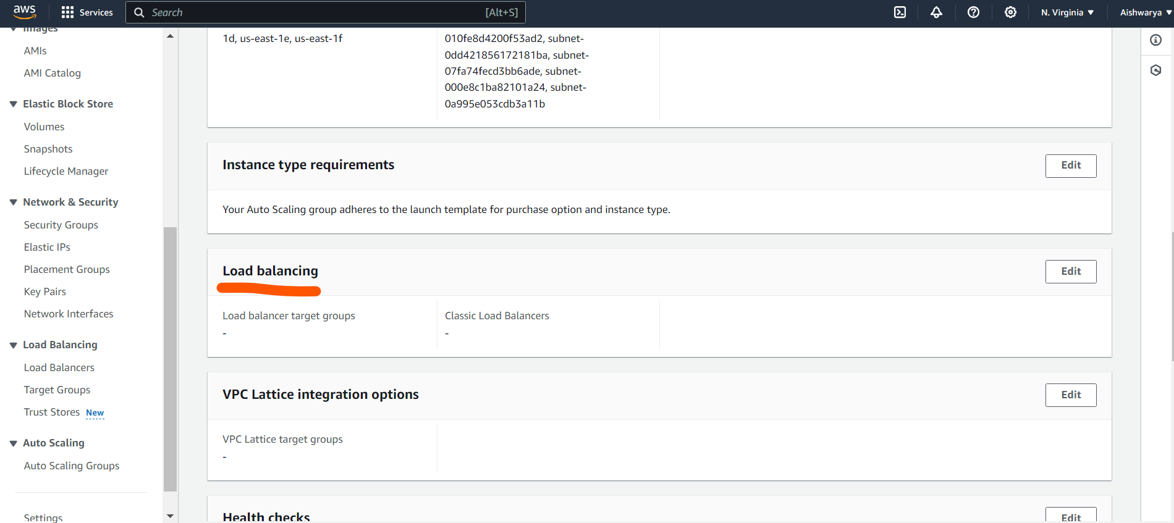

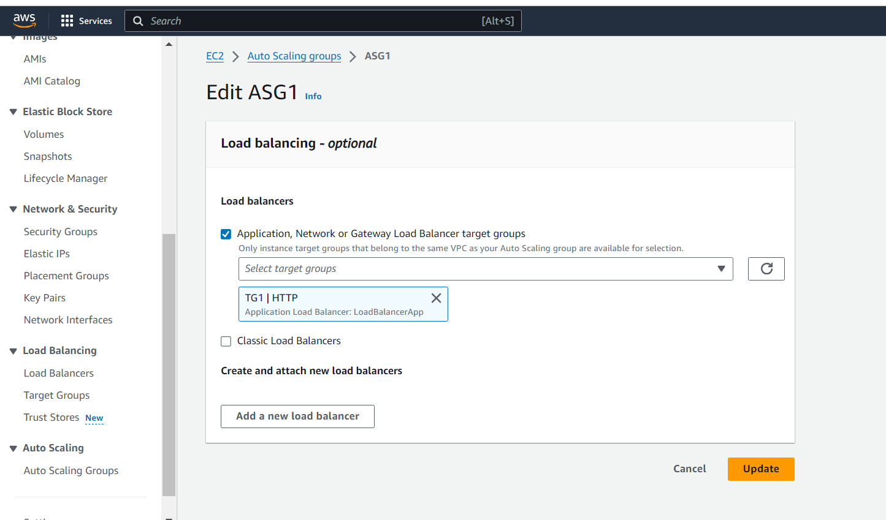

Now in TG we can see instances of ASG

